 | Epsom & Ewell F.C.  21  v  Cove  Saturday, 7th March 2015
For our league match this afternoon we welcome the players and officials of Cove along with today's match officials and of course our own regular supporters.

Our opponents have had a very good season and are right in the thick of the title battle with a virtual guaranteed of a top four finish to earn the F.A.Vase exemption that we denied them last season by losing to Westfield on the final day of the season. Sorry about that!

Cove edged us out 1-0 at Oak Farm back in November to record a very rare home win in this sequence. Along with Hanworth Villa, and prior to that Egham Town and Bracknell Town, both teams seem to perform better in the away matches than they do the home ones. This obviously is not a good sign for us as hosts today, but if they can win at home, why can’t we?

For what it’s worth I thought we were massively unfortunate to lose that away match, having created the bulk of the chances, but as we found out against Camberley Town a week ago, you have to take your chances when you have the opportunity.

We were last here just four days ago when a frozen crowd witnessed an injury time equaliser from Kyle Hough in a 1-1 draw with Hanworth Villa. This is now the fifth time that Kyle has reached twenty goals in a season, something achieved by just two other players in club history, Tommy Tuite and Reg Marlow. When you consider that he didn’t open his account for the season until our thirteenth game of the season, it shows that he is bang in form.

In addition, Kyle should join the 300 appearance club today, raising the number of members in that elite group to thirteen, and although we always hope that he has success in front of goal, that sentiment is particularly relevant today. There is more on his 300 later on.

Following today’s match we are scheduled to travel to Raynes Park Vale for a League match on Tuesday and whilst the weather is improving, the pitch at Grand Drive is having a lot of trouble right now so please check the website and Twitter for details, just in case.

On Saturday we return to Chertsey Town for the first time in a few years. Personally I shall never forget our sponsored walk there in 2004 which was really painful, as was the performance that day! Hopefully we can gain some revenge for our 2-1 home defeat earlier in the season. Then in two weeks we return here to host Badshot Lea; a team we have had real trouble with results-wise in recent years.

Thanks for watching today. Glyn, the lads and the club value your support. Don’t forget your Super Six tickets – the jackpot is now £326!!

Rich

Cover photo this week by Gemma Jarman

Kyle Hough scores our injury time equaliser against
Hanworth Villa on Tuesday evening


Cherry Red Records
Combined Counties League
Premier Division Table 2014/15
inc Tuesday  3rd March 2015 | P | W | D | L | F | A | Pts | GD | H | A
Camberley Town | 30 | 22 | 5 | 3 | 74 | 22 | 71 | +52 | 2-4 | 0-1
Cove | 31 | 22 | 5 | 4 | 76 | 46 | 71 | +30 | 7/3 | 0-1
Molesey | 26 | 20 | 0 | 6 | 76 | 25 | 60 | +51 | 1-3 | 8/4
Ashford Town (Mx) | 29 | 19 | 3 | 7 | 72 | 37 | 60 | +35 | 2-4 | 3-1
Windsor | 31 | 18 | 4 | 9 | 71 | 42 | 58 | +29 | 0-5 | 11/4
Spelthorne Sports | 30 | 16 | 3 | 11 | 60 | 49 | 51 | +11 | 4-3 | 3-0
Hartley Wintney | 31 | 14 | 4 | 13 | 42 | 55 | 46 | -13 | 2-1 | 1-2
Badshot Lea | 28 | 13 | 5 | 10 | 60 | 46 | 44 | +14 | 21/3 | 2-4
Farnham Town | 28 | 12 | 5 | 11 | 64 | 64 | 41 | 0 | 2-4 | 2-0
Bedfont Sports | 29 | 12 | 3 | 14 | 45 | 52 | 39 | -7 | 0-1 | 2-0
Colliers Wood United | 30 | 11 | 4 | 15 | 52 | 54 | 37 | -2 | 4/4 | 2-3
Epsom & Ewell | 28 | 11 | 3 | 14 | 51 | 53 | 36 | -2 | - | -
Mole Valley SCR | 29 | 10 | 5 | 14 | 51 | 73 | 35 | -22 | 1-0 | 5-2
Chertsey Town | 31 | 10 | 4 | 17 | 50 | 70 | 34 | -20 | 1-2 | 14/3
Raynes Park Vale | 25 | 8 | 5 | 12 | 34 | 44 | 29 | -10 | 0-1 | 10/3
Knaphill | 29 | 8 | 5 | 16 | 37 | 65 | 29 | -28 | 18/4 | 4-1
Westfield | 27 | 7 | 7 | 13 | 38 | 50 | 28 | -12 | 24/3 | 0-4
Horley Town | 28 | 6 | 7 | 15 | 53 | 76 | 25 | -23 | 2-2 | 6/4
Hanworth Villa | 28 | 6 | 6 | 16 | 40 | 58 | 24 | -18 | 1-1 | 5-2
Frimley Green | 30 | 6 | 4 | 20 | 46 | 79 | 22 | -33 | 0-0 | 25/4
Guildford City | 26 | 6 | 3 | 17 | 44 | 76 | 21 | -32 | 4-1 | 28/3

Lucky Day? – 7th March
Played 14 - Won 7 Drawn 2 Lost 5 - F 22 A 24 - PPG 1.64 - Above Average
Club record against Cove
Played 31 - Won 13 Drawn 8 Lost 10 - F 65 A 53 - PPG 1.52 - Above Average
Last visit
Tuesday 8th April 2014 - Lost 1-0 - Combined Counties League

First Eleven Appearances - (max 37 inc Hanworth Villa)
Name | Debut | 2014/15 |  |  |  | Career Totals
Name | Debut | App | Sub | Total | Goals | App | Sub | Total | Goals
BROWN Oshane* | 30/08/2014 | 2 | 0 | 2 | 0 | 2 | 0 | 2 | 0
BURNS Robbie | 14/08/2007 | 3 | 1 | 4 | 0 | 205 | 15 | 220 | 121
COOPER-SMITH Daryl | 03/01/2015 | 4 | 2 | 6 | 2 | 4 | 2 | 6 | 2
CURRIE Sam | 04/08/2012 | 5 | 3 | 8 | 0 | 99 | 8 | 107 | 2
DEAN Dan | 02/08/2014 | 27 | 1 | 28 | 0 | 27 | 1 | 28 | 0
DEWAR Ali | 29/10/2011 | 5 | 6 | 11 | 3 | 55 | 35 | 90 | 10
DOUGLIN Karl* | 03/08/2013 | 1 | 0 | 1 | 1 | 41 | 3 | 44 | 14
DOWNS Carl* | 17/09/2011 | 4 | 1 | 5 | 0 | 94 | 13 | 107 | 2
EACOTT Michael | 02/08/2014 | 35 | 0 | 35 | 0 | 35 | 0 | 35 | 0
FARRELL Matt | 02/08/2014 | 31 | 3 | 34 | 4 | 31 | 3 | 34 | 4
FERDINANDO Matt | 20/09/2014 | 20 | 3 | 23 | 6 | 20 | 3 | 23 | 6
FRANKLIN Ben | 03/03/2015 | 1 | 0 | 1 | 0 | 1 | 0 | 1 | 0
GAFFNEY Luke* | 16/08/2014 | 10 | 1 | 11 | 0 | 10 | 1 | 11 | 0
HARPER Tommy* | 15/04/2014 | 1 | 0 | 1 | 0 | 2 | 1 | 3 | 0
HAYWARD Ben | 07/03/2007 | 6 | 0 | 6 | 0 | 242 | 28 | 270 | 18
HOADLEY Harry* | 27/08/2011 | 6 | 1 | 7 | 0 | 7 | 1 | 8 | 0
HOUGH Kyle | 14/08/2007 | 30 | 3 | 33 | 20 | 284 | 15 | 299 | 157
JARMAN Mark* | 08/08/2009 | 5 | 5 | 10 | 0 | 136 | 51 | 187 | 76
MARVELL Dale* | 15/01/2000 | 11 | 5 | 16 | 5 | 261 | 45 | 306 | 85
MCGREGOR Alex | 08/08/2009 | 13 | 2 | 15 | 1 | 170 | 56 | 226 | 27
MCKAY Alex | 20/12/2008 | 9 | 4 | 13 | 1 | 74 | 26 | 100 | 8
MURPHY George | 28/03/2013 | 22 | 1 | 23 | 1 | 63 | 5 | 68 | 3
MUTIMA Lionel* | 05/08/2014 | 4 | 2 | 6 | 0 | 4 | 2 | 6 | 0
NELMES Elliott* | 05/08/2014 | 2 | 0 | 2 | 0 | 2 | 0 | 2 | 0
PANAYI Anthony | 14/11/2010 | 29 | 1 | 30 | 0 | 156 | 15 | 171 | 4
PANAYIOUTOU Savva | 03/01/2015 | 6 | 1 | 7 | 1 | 6 | 1 | 7 | 1
ROBINSON Matt | 01/12/2012 | 17 | 2 | 19 | 3 | 18 | 5 | 23 | 4
ROBINSON Sam | 22/10/2011 | 21 | 1 | 22 | 6 | 45 | 4 | 49 | 11
ROWE Steve | 27/08/2011 | 10 | 1 | 11 | 0 | 15 | 2 | 17 | 0
SHAW Ollie* | 20/09/2014 | 0 | 10 | 10 | 0 | 0 | 10 | 10 | 0
SMITH Matt | 08/08/2009 | 0 | 1 | 1 | 0 | 91 | 43 | 134 | 10
SMITH Taylor* | 02/08/2014 | 13 | 2 | 15 | 7 | 13 | 2 | 15 | 7
TANTON Matt | 02/08/2014 | 18 | 4 | 22 | 1 | 18 | 4 | 22 | 1
TAYLOR James | 26/08/2013 | 30 | 1 | 31 | 2 | 47 | 7 | 54 | 3
VAN GELDER Julian* | 12/09/2006 | 0 | 1 | 1 | 0 | 0 | 2 | 2 | 0
WHITE Sean* | 02/08/2014 | 6 | 13 | 19 | 3 | 6 | 13 | 19 | 3
Own Goal |  |  |  |  | 1
* Player has left the club

Anthony Panayi
Good afternoon!

Today we welcome Cove to High Road after a tough mid-week clash with Hanworth Villa.

Earlier this year we felt we were very unlucky against Cove not to come away with anything from the game with the amount of possession we endured at their place.

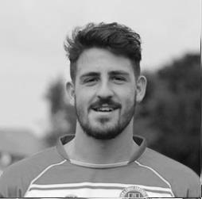
Today we know we must show the same amount of passion and desire as we demonstrated in the last 20 minutes of the game on Tuesday. Moving forward we know we have a lot to work on and all the players are extremely keen to do so.

It's not been the year that we are used to in recent times here at Epsom and it's something we all want to put right and have a strong end to the season!

Once again, thanks again for your continued support!

Ant

Results and Fixtures
Surrey Senior Cup QF – Tuesday 3rd March
Molesey | 2-0 | Badshot Lea
Combined Counties League – Tuesday 3rd March
Epsom & Ewell | 1-1 | Hanworth Villa
Mole Valley SCR | 1-4 | Camberley Town
Spelthorne Sports | 0-1 | Hartley Wintney
Westfield | 1-1 | Colliers Wood United
Combined Counties League – Saturday 7th March
Chertsey Town | V | Farnham Town
Epsom & Ewell | V | Cove
Guildford City | V | Ashford Town (Mx)
Hanworth Villa | V | Windsor
Horley Town | V | Westfield
Knaphill | V | Bedfont Sports
Mole Valley SCR | V | Frimley Green
Molesey | V | Badshot Lea
Raynes Park Vale | V | Camberley Town
Spelthorne Sports | V | Colliers Wood United
Surrey Senior Cup SF – Tuesday 10th March
Merstham | V | Ashford Town (Mx)
Combined Counties League – Tuesday 10th March
Badshot Lea | V | Hanworth Villa
Results and Fixtures
Combined Counties League – Tuesday 10th March
Hartley Wintney | V | Guildford City
Mole Valley SCR | V | Farnham Town
Molesey | V | Cove
Raynes Park Vale | V | Epsom & Ewell
Spelthorne Sports | V | Windsor
Westfield | V | Camberley Town
Combined Counties League Cup QF – Wednesday 11th March
Colliers Wood United | V | Badshot Lea
Combined Counties League – Saturday 14th March
Badshot Lea | V | Frimley Green
Bedfont Sports | V | Molesey
Chertsey Town | V | Epsom & Ewell
Colliers Wood United | V | Mole Valley SCR
Cove | V | Camberley Town
Farnham Town | V | Hartley Wintney
Guildford City | V | Hanworth Villa
Knaphill | V | Westfield
Raynes Park Vale | V | Spelthorne Sports
Windsor | V | Ashford Town (Mx)
Combined Counties League – Tuesday 17th March
Badshot Lea | V | Horley Town
Bedfont Sports | V | Hanworth Villa
Farnham Town | V | Colliers Wood United
Knaphill | V | Frimley Green
Molesey | V | Ashford Town (Mx)
Westfield | V | Raynes Park Vale
Combined Counties League – Wednesday 18th March
Guildford City | V | Cove
Combined Counties League Cup QF – Saturday 21st March
Worcester Park | V | Windsor
Combined Counties League – Saturday 21st March
Bedfont Sports | V | Chertsey Town
Epsom & Ewell | V | Badshot Lea
Farnham Town | V | Camberley Town
Frimley Green | V | Guildford City
Hanworth Villa | V | Ashford Town (Mx)
Hartley Wintney | V | Molesey
Horley Town | V | Colliers Wood United
Mole Valley SCR | V | Knaphill
Raynes Park Vale | V | Cove
Spelthorne Sports | V | Westfield

From behind the goal
Epsom & Ewell 1-1 Hanworth Villa
Combined Counties League - Premier Division - Tuesday 3rd March 2015

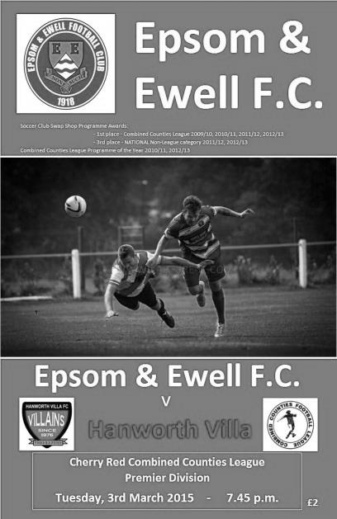
Hough rescues point for Salts in disappointing performance

It's hard to say whether the Salts deserved a point from Tuesday's encounter at High Road. In terms of possession the visitors just shaded it, but in terms of never giving up and fighting all the way to the final whistle, it was probably a fair result.

Glyn made three changes to the eleven that started the League Cup tie with Camberley. At left back Ben Franklin made his debut in place of Steve Rowe, while Matt Farrell had a family emergency and was replaced in the line-up by the fit again Robbie Burns. Finally, Savva 'Agi' Panayiotou took the place of Alex McGregor on the left. Additionally Alex McKay made his hundredth appearance for our club and had a good game. In the opposition line up was former long-serving Epsom player Dale Marvell; intriguingly now playing as a right back, where on this performance and despite being 35 later this year, he appears to have some more mileage left in the tank.

In fact this was a game where both defences did fairly well and James Taylor set the tone in the second minute with a superb goal line clearance under pressure after Franklin had been dispossessed, which had led to a shot on goal from the right flank. Both teams packed the midfield and space was at a premium, which led to a fairly scrappy first half.

The two best opportunities of scoring in this half also came from defenders, although their attempts were at the wrong end! Firstly, McKay sliced a clearance straight towards the top corner of his own net but Michael Eacott was alert to make the best save of his Epsom career to claw the ball away as it was already past him. Think David Seaman against Sheffield United in that FA Cup tie, and if you can't remember that far back, there's always Youtube! At the other end a dangerous cross from substitute Steve Rowe was headed narrowly past the post by a defender.

Rowe was on the field as an early substitute after the unlucky Franklin had been unable to continue after having his knee trodden on. Whether that was a deliberate or an accidental incident, it is hard to say from where I was. However, the game was becoming quite niggly and there was an off the ball incident just before the half with one of our players ending in a heap on the floor. Our players were angry about this but the officials were looking the other way and didn't appear to see anything. A couple of decent shots from Sam Robinson were powerful enough but just wide of the goal, as was an attempt from Robbie Burns after 42

minutes who could only hit the side netting from a wide angle. The visitors had nearly taken the lead before that after a fine left wing run and deep cross, requiring Rowe to head the ball away as it threatened to drop in at the back post.

The second half started evenly, but following a foul on Panayiotou that everyone stopped for except the referee, the visitors broke and nearly scored from the counter attack; their shot being fired just wide. In the 56th minute they gained a free kick on the edge of the area, despite much protest from our players who were beginning to feel a little hard done by at this point. However, there was no doubting that Hanworth Villa were getting on top and although Eacott tipped the well-struck free kick over, a clumsy challenge on their Captain in the 59th minute conceded a penalty, earning our young keeper a yellow card for his trouble and their player a dislocated shoulder. It was a big collision and our player was maybe fortunate that their striker was heading away from goal at the time or the consequences could have been worse. After a break for treatment and a substitution, Adam Baigent stroked the penalty in with the clock on the 62 minute mark.

What sort of response would this provoke? Well, not long after the goal Sam Robinson was replaced by his brother Matt who moved out to the right with Matt Ferdinando playing more centrally, while on the left Alex McGregor came on for Panayiotou. It's fair to say that all three substitutes played well in this match and as the game reached the final quarter of an hour we began to exert some pressure of our own. After 75 minutes Sam Currie met a Matt Robinson corner at the near post but his contact was too firm and the ball went over the bar when a lesser connection would probably have gone in, as he got a good jump on the ball.

After 85 minutes a good bit of pressure resulted in a ball through to Burns but he was flagged offside just as he put the ball in the net. Well aware of the visitors’ recent record in conceding late goals, our boys continued to push forward. As the game entered the last of the regulation 90 minutes a long ball from Eacott was beyond Marvell and controlled superbly by McGregor who ran in at goal from the left, cutting back on to his favoured right foot but the shot lacked power and was saved fairly comfortably by Dane Buss. Still, it was our first actual shot on target in the match and I'm pleased to report that another followed in injury time when the ball was threaded through to Kyle Hough and his shot was half stopped by the keeper but had enough momentum to cross the line for the late equaliser.

It would be easy to feel sorry for the visitors in conceding another late goal as they battle to avoid relegation. However, it should be remembered that in our three recent visits to the Ranch we have conceded five goals in second half injury time, costing us five points in total, so you'll understand that maybe we were due! More concerningly, our overall performance was flat for a large part of the game, which is frustrating as in each of our last four games since our winter break we have looked really good in parts, two of which were against the league leaders. Yes, the absence of Farrell, coupled with the injured Dan Dean and George Murphy do not help our plight, but I doubt there is a single team in the League that doesn't have a player or two out right now and we just have to step up. The final 15 minutes of this match tell me that we are more than capable of doing so and we just need to do it for the full ninety minutes next time.

Team: Michael Eacott, James Taylor, Ben Franklin, Anthony Panayi, Alex McKay, Sam Currie ©, Savva Panayiotou, Sam Robinson, Kyle Hough, Robbie Burns, Matt Ferdinando

Subs: Steve Rowe for Franklin (39), Matt Robinson for Robinson (70), Alex McGregor for Panayiotou (76)

Kyle Hough – 300 games!
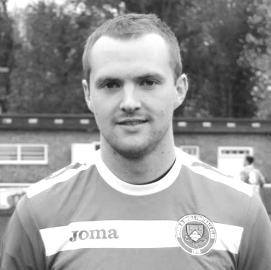
This afternoon, Kyle Hough should make his 300th appearance for the club, becoming only the thirteenth player in club history to reach that milestone, and the second this season after Dale Marvell. It was unfortunate that our trip to Molesey was off last Saturday or he’d have reached the mark while playing against Dale’s new club, Hanworth Villa!

Kyle has been with us for the majority of the last eight seasons. He took a season out with Horley to whom he returned briefly at the end of last term and had a try at Walton Casuals a few years back but for some reason didn’t have the success that we all thought he would and their loss was our gain as he came back to us.

He was born on 8th December 1987 and joined us from Corinthian Casuals where he had played under Lyndon Buckwell before he became Manager of our club in the October of 2006. Kyle made his debut for us three days later than planned, on Tuesday 14th August 2007 against Colliers Wood United. It should have been at Chertsey Town on opening day but the game was postponed due to the referee being unhappy with the condition of the Alwyns Lane pitch following summer drainage works! We lost to Colliers Wood 2-1 on a very wet Tuesday evening and it took Kyle until his fourth game, ironically at home to Horley Town before he opened his account in our 2-1 win.

There were once many similarities with striking partner Robbie Burns, as they both made their debuts and scored their first goal on the same day as each other, but Robbie’s absence over the last few years has enabled Kyle to pull away from his team mate.

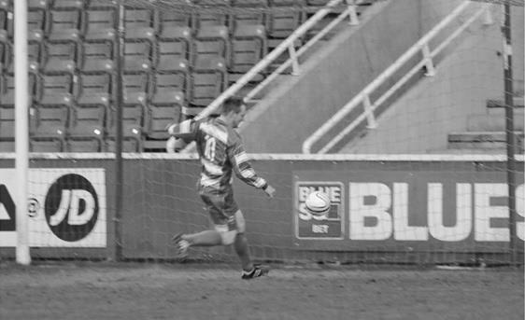
We have had very few players in recent years that are able to play in so many different positions, and Kyle often suffered for his versatility by being played out wide; a position he still occupies occasionally, but since being the spearhead of our attack, he has started to find the net again with regularity, and on Tuesday scored his twentieth goal for the club, the fifth time he has done this; a huge achievement, especially when you realise that in his other two seasons with us he managed 17 and 18 and in neither of those seasons were we a top half team. Other legendary strikers at our club like Robbie, or further back Steve Hill and Jimmy Jones only had four seasons reaching that mark, so only Reg Marlow (7) and Tommy Tuite (10) sit ahead of him.

Kyle scores our first goal in the League Cup Final v South Park after 29 minutes on 10th May 2013

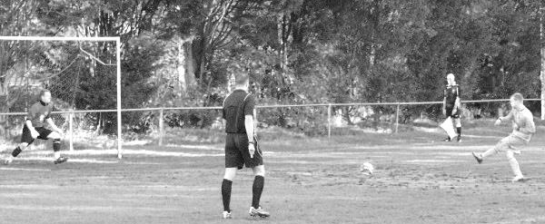
This is also reflected in the Club Hall of Fame, where Kyle now sits proudly in third place out of the nearly 2, 000 players who have appeared in our first eleven. It may be that he will always have these two prolific marksmen ahead of him, but Marlow sits “just” the 97 goals ahead as I write, so if Kyle remained with us and kept scoring at his current rate, he would pass him in late 2018, by which time Kyle would still only be 30. It’s a tall order, but no longer is it an impossible dream.

Of course mention also has to be made of Kyle’s complete re-writing on the history books with regard to penalties. Since his very first for the club in a 1-1 draw at Bookham on 4th September 2007 he has scored an incredible 48 penalties for our club. He also holds another club record for scoring nine in a season, which he has done twice.

From a penalty save by Dean Cupit for Bookham on 16th February 2008 until he hit the post against Craig Bradshaw for Chertsey Town on 15th January 2011 he hit the mark 27 times in a row! The 26th of these was at Colliers Wood United and is shown below. Of all his penalties though, the most important ones came down in deepest Somerset when we edged Wellington AFC out by three goals to two after extra time and he scored twice from the spot.

He has also scored five hat tricks, including two in consecutive games at Hanworth Villa and Dorking and scored the opening goal in our League Cup Final win over South Park in May 2013. One thing he hasn’t yet done for us is score a hat trick in front of the home supporters but he has come close on many, many occasions and there is still plenty of time for this to happen.

Thanks for the memories Kyle. Here’s to many more!

Achievement | Date | Against | Score
50th appearance | 03/05/08 | Horley Town (A) | 1-0
100th appearance | 18/04/09 | Bedfont Green (A) | 2-4
150th appearance | 28/08/10 | Flackwell Heath (H) | 3-2
200th appearance | 02/10/12 | Horley Town (A) | 1-1
250th appearance | 24/09/13 | Wembley (H) | 0-2
300th appearance | 07/03/15 | Cove (H) ? | ?-?
50th goal | 27/10/09 | Ash United (A) | 1-4
100th goal | 05/01/13 | Ash United (H) | 5-2
150th goal | 13/12/14 | Badshot Lea (A) | 2-4

Club Records - 7th March
Date | Day | Competition |  | Opponents |  | Scorers
07/03/25 | Sat | Friendly | H | Fulham Reserves | 2-4 | T.Edwards (2)
07/03/31 | Sat | London League | H | Dagenham Town | 2-1 | R.Marlow, H.Pattimore
07/03/36 | Sat | London League | A | Eton Manor | 1-1 | J.Parr
07/03/53 | Sat | Corinthian League | H | Edgware Town | 1-0 | J.Crane (pen)
07/03/59 | Sat | Corinthian League | A | Erith & Belvedere | 3-2 | B.Russell (3)
07/03/70 | Sat | Athenian League 2 | H | Edmonton | 1-4 | K.Gregory
07/03/81 | Sat | Isthmian League 1 | A | Ware | 2-1 | P.Gaydon, J.Auguste
07/03/85 | Thur | Isthmian League Premier | H | Worthing | 2-1 | M.Stratford, S.Hill
07/03/87 | Sat | Isthmian League 1 | H | Leytonstone/Ilford | 0-2
07/03/92 | Sat | Isthmian League 3 | H | Kingsbury Town | 2-0 | M.Pepper, A.Skeet
07/03/98 | Sat | Isthmian League 3 | A | Hertford Town | 1-2 | S.Smith
07/03/00 | Tue | Isthmian League 3 | H | Abingdon Town | 1-1 | S.Latuske
07/03/07 | Wed | Combined Counties Premier | A | Guildford City | 0-4
07/03/09 | Sat | Combined Counties Premier | H | Bookham | 4-1 | B.Hayward, G.McLaughlin, D.Marvell, K.Hough
Historical Decades
90 years ago – Epsom Town
07/03/25 | Sat | Friendly | H | Fulham Reserves | 2-4 | T.Edwards (2)
80 years ago – Epsom F.C.
09/03/35 | Sat | London League | A | Bostall Heath | 0-2
70 years ago – War time Epsom Town
03/03/45 | Sat | South Eastern Comb. | H | Erith & Belvedere | 0-1
60 years ago – Epsom F.C.
05/03/55 | Sat | Corinthian League | H | Worthing | 0-3
50 years ago – Epsom & Ewell
06/03/65 | Sat | Athenian League 1 | A | Slough Town | 1-4 | G.Jasper
40 years ago – Epsom & Ewell
08/03/75 | Sat | Surrey Senior League | A | Merstham | 3-0 | P.O'Connell, P.Walker, D.Ritman
30 years ago – Epsom & Ewell
07/03/85 | Thur | Isthmian League Premier | H | Worthing | 2-1 | M.Stratford, S.Hill
20 years ago – Epsom & Ewell
11/03/95 | Sat | Isthmian League 3 | H | Northwood | 2-0 | S.Miller (2)
10 years ago – Epsom & Ewell
12/03/05 | Sat | Isthmian League 2 | H | Witham Town | 0-5

History Corner – 7th March
90 years ago today regular full back Tom Edwards went up front as an experiment in this friendly challenge match at home to Fulham Reserves at the Horton Hospital Grounds. It’s fair to say that he had a measure of success, scoring twice, but his replacement let him down as we let four in at the other end!

84 years ago today we defeated Dagenham Town by two goals to one at West Street. (see programme pictured) On a freezing day we went 2-0 up in the first twenty five minutes through Reg Marlow and Herbert Pattimore and then hung on to win, effectively playing with nine fit men after George Mackesy and Trevor Jones suffered injury. Although this Dagenham were the main club in the town, they are not connected to the current Football League team, which founded just after World War Two.

70 years ago this week the war time Epsom Town club hosted the all-conquering Erith & Belvedere side and according to the papers, we were the better side, but just couldn’t find a way past the “invincible” Day in goal for the visitors. A single goal won it for the opposition.

55 years ago today Bobby Russell made his debut after joining from Finchley and opened the scoring after just two minutes against Erith & Belvedere at their old Park View ground. After 35 minutes he had completed his hat trick, setting a club record in the process. We held on to win 3-2 but incredibly Russell never scored again for the club, making just three appearances in total.

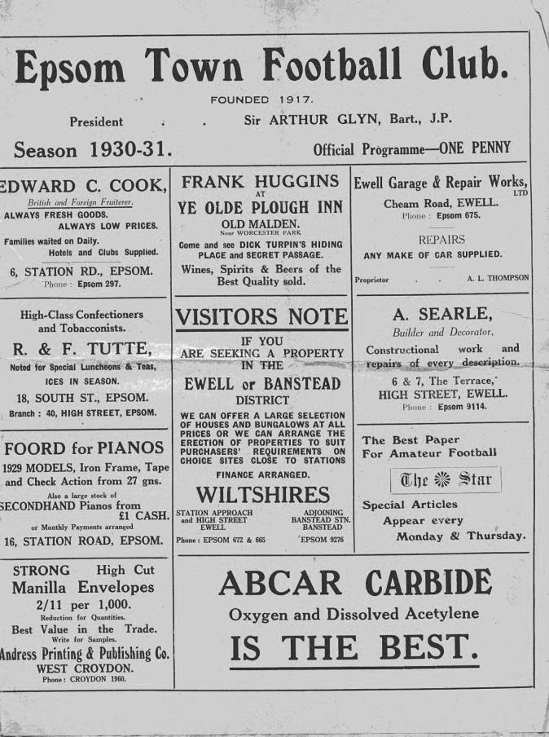
30 years ago today Worthing visited West Street on a Thursday evening and in a bad tempered match, goals from Mick Stratford and Steve Hill ensured a 2-1 win. As their keeper Simon Steele left the field he spat at some of our supporters. Lovely chap!

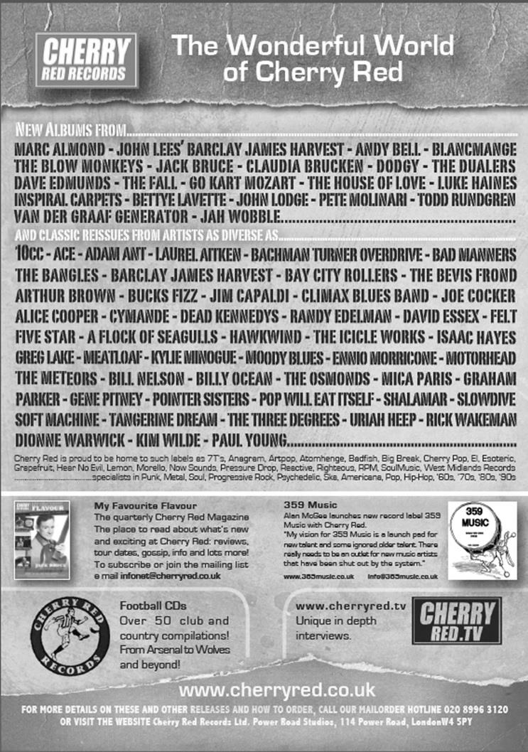


Centre page for results

Centre page for results

Cups – The latest position

EL Records Premier Challenge Cup
Quarter Finals
Colliers Wood Utd | 11/3 | Badshot Lea
Worcester Park | 21/3 | Windsor
Epsom & Ewell | 2-4 | Camberley Town
Farnham Town | v | Cove

Surrey Senior Cup
Quarter Finals
Ashford Town (Mx) | 3-1 | Westfield
Colliers Wood Utd | 0-2 | Merstham
Molesey | 2-0 | Badshot Lea
Met Police | 2-1 | Tooting & Mitcham
Semi Finals
Molesey | 18/3 | Met Police
Merstham | 10/3 | Ashford Town (Mx)

F.A. Vase
Quarter Finals – 28th February
AFC St Austell | 3-2 | Ascot United
South Western Peninsula | 3-2 | Hellenic
Erith & Belvedere | 0-2 | North Shields
Southern Counties East | 0-2 | Northern
Shaw Lane Aquaforce | 2-2+ | Glossop North End
Northern Counties East | 2-2+ | North West Counties
Replay 7th March
Highworth Town | 1-1+ | Tadcaster Albion
Hellenic | 1-1+ | Northern Counties East
Replay 7th March
Semi Finals – 21st and 28th March – two legs
Highworth / Tadcaster | V | North Shields
Shaw Lane / Glossop | V | AFC St Austell

Club Milestones
It’s like London Buses! You wait for a milestone and then three come around all at once!

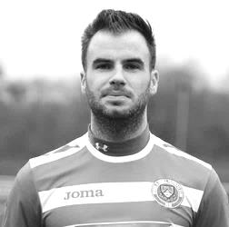
In addition to Kyle Hough who we have covered earlier in this issue, Alex McKay made his 100th appearance for the club on Tuesday against Hanworth Villa. He was originally projected to reach this mark a couple of weeks ago but absence followed by illness prevented him doing this.

Alex has been with us, on and off, for quite a while now, actually making his debut way back on 20th December 2008 for our top two contest at Merland Rise against eventual Champions Bedfont Green.

He has proven to be quite adaptable, often playing in front of the back four instead of being part of it, and I recall one game at South Park, where it just looked as though they wouldn’t get though, as he was protecting our boys so well.

His “footballing CV” has grown this season as he is now one of our Player / Coaches at the club and in November he qualified as a referee. In tribute to his qualification, he then travelled all the way over to Molesey for our League match, instead of coming to Chipstead, as we were actually playing at home!!

He is the 115th player in club history to reach that mark, which might sound like a lot of people but as we have been a Senior club for just 91 seasons, it is only just over one a year, so is a significant achievement.

Congratulations Alex!

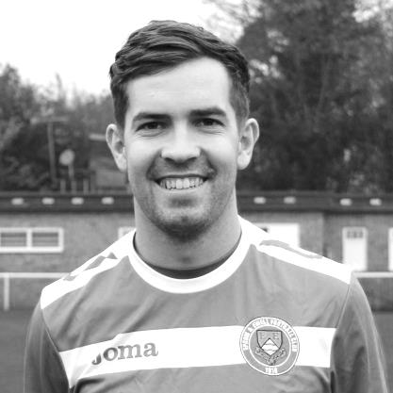
Next up is Sam Robinson who will hopefully make his 50th appearance for our club this afternoon.

Sam has had two spells at the club; firstly during our time at Merstham, joining us from the Moatside club and making his debut on 22nd October 2011 in our 4-1 defeat at Wembley, although he was most remembered in that spell for two goals against the high flying South Park in our 3-1 win against them in November of that year. He made 14 appearances in that spell before departing to Faversham Town. He re-joined us in August, effectively as a replacement for the departed Karl Douglin and it is fair to say that he has had a mixed season. He scored a great hat trick in our 5-2 win at Hanworth Villa, but has also picked up a number of suspensions that prevented him reaching the 50 mark some time ago. His brother Matt also plays for us while other brother Ollie plays for Molesey currently.

He becomes the 256th player in our history to reach this mark. Congratulations Sam!

CCL Premier Division Club Directory
ASHFORD TOWN (Mx) Telephone: 01784-245908 - Ground: The Robert Parker Stadium, Short Lane, Stanwell. TW19 7BH - Colours: Tangerine & White Stripes/Black/Tangerine

BADSHOT LEA Telephone: 01252-320385 - Ground: Ash United FC, Shawfield Stadium, Youngs Drive, Shawfields Road, Ash, Hampshire. GU12 6RE - Colours: Claret/White/Claret

BEDFONT SPORTS Telephone: 0208-831-9067 - Ground: Bedfont Sports Club, Hatton Road, Bedfont, Middx TW14 8JA - Colours: Red & Black Hoops/Black/Red & Black Hoops

CAMBERLEY TOWN Telephone: 01276-65392 - Ground: Krooner Park, Wilton Road, Camberley, Surrey. GU15 2QW - Colours: Red & White Stripes/Blue/Red

CHERTSEY TOWN Telephone: 01932-561774 - Ground: Alwyns Lane, Chertsey, Surrey. KT16 9DW - Colours: Royal Blue & White Stripes/Royal Blue/Royal Blue

COLLIERS WOOD UNITED Telephone: 0208-942 8062 - Ground: Wibbandune Sports Ground, Lincoln Green, Opposite 199-213, Robin Hood Way, Wimbledon. SW20 0AA - Colours: Blue & Black Stripes/Black/Black

COVE Telephone: 01252-543615 - Ground: Oak Farm Fields, 7 Squirrel Lane, Cove, Farnborough, Hampshire. GU14 8PB - Colours: Yellow/Black/Yellow

EPSOM & EWELL Telephone: 01737-553250 - Ground: Chipstead FC, High Road, Chipstead, Surrey. CR5 3SF - Colours: Royal Blue & White Hoops/Royal Blue/Royal Blue & White Hoops

FARNHAM TOWN Telephone: 01252-715305 Ground: Memorial Ground, Babbs Mead, West Street, Farnham, Surrey. GU9 7DY Colours: - Claret & Sky Blue /White/ Claret & Sky Blue

FRIMLEY GREEN Telephone: 01252-835089 - Ground: Frimley Green Recreation Ground, Frimley Green Road, Frimley Green, Camberley, Surrey. GU16 6JY - Colours: Blue & White/Blue/Blue

GUILDFORD CITY Telephone: 01483-443322 - Ground: The Spectrum, Parkway, Guildford, Surrey. GU1 1UP - Colours: Red & White Stripes/Black/Black

HANWORTH VILLA Telephone: 0208-831-9391 - Ground: Rectory Meadows, Park Road, off Hounslow Road, Hanworth, Middlesex. TW13 6PN - Colours: Red & White Stripes/Black/Black

HARTLEY WINTNEY Telephone: 01252-843586 - Ground: Memorial Playing Fields, Green Lane, Hartley Wintney, Hants RG27 8DL - Colours: Orange & Black/ Orange /Orange

HORLEY TOWN Telephone: 01293-822000 - Ground: The New Defence, Anderson Way, Court Lodge Road, Horley, Surrey. RH6 8SP - Colours: Claret & Sky Blue/Claret/Claret

KNAPHILL Telephone: 01483-475150 - Ground: Brookwood Country Park, Redding Way, Lower Guildford Road, Knaphill, Surrey. GU21 2AY - Colours: Red/Black/Red

MOLE VALLEY SCR Telephone: 01932-866386 - Ground: Cobham FC, Leg O’Mutton Field, Anvil Lane, Downside Bridge Road, Cobham, Surrey KT11 1AA - Colours: Yellow/Black/Black

MOLESEY Telephone: 0208-979-4283 - Ground: 412 Walton Road, West Molesey, Surrey KT8 2JG - Colours: White/Black/Black

RAYNES PARK VALE Telephone: 020-8540-8843 - Ground: Prince Georges Playing Field, Grand Drive, Raynes Park, London. SW20 9NB - Colours: Blue/Blue/Red

SPELTHORNE SPORTS Telephone: 01932-961055 - Ground: Spelthorne Sports Club, 296 Staines Road, Ashford Common, Ashford, Middx. TW15 1RY - Colours: Light & Dark Blue/Dark Blue/Light Blue

WESTFIELD Telephone: 01483-771106 - Ground: Woking Park, Kingfield Road, Woking, Surrey. GU22 9BA - Colours: Yellow/Black/Black

WINDSOR Telephone: 01753-860656 - Ground: Stag Meadow, St Leonards Road, Windsor, Berks SL4 3DR - Colours: Red/Red/Red

Cove F.C. – History
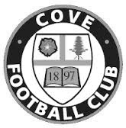
Cove F.C. were formed in 1897 by a group of local people playing on a field behind their favourite Public House.
Moving to a more central location, Cove Green became their home until 1973, when they moved to their present ground at Oak Farm. Playing their football in The Surrey Leagues, Cove enjoyed success for many years, winning more than their fair share of silverware in this time, including the League Championship three years in succession and a double.

In 1973, the club decided to upgrade and were accepted into the Hampshire Leagues, but had to leave 'The Green' for safety reasons. The Division 4 Championship was won at the first attempt, and the Division 3 title followed 2 years later. After a couple of seasons, Cove finished Runners-Up in Division 2, but decided to withdraw from this league due to the time taken to away matches in Portsmouth or Southampton, before the M3 motorway was built.

Thus they returned to the more local Combined Counties League in 1980, and won the League Cup beating close neighbours and rivals Ash United. Since moving into their new home, many changes have taken place at Oak Farm with the installation of floodlights a concrete perimeter wall and stand in their quest to house senior non-league football. These achievements are the more remarkable with Farnborough Town (then Conference League) and Aldershot Town (then Football League) just a couple of miles down the road.

In 1990, Cove were given the chance to join the Vauxhall League (now Ryman League) after finishing third. New manager ‘Chick’ Botley assembled a squad strong enough to finish a respectable fourth in their first season. Two more successful seasons followed narrowly missing out on promotion, once a final day defeat by the new Aldershot Town. Due to the ever spiralling cost of football at this level, Cove were forced to withdraw and had to revert back into The Combined Counties League, where they remained with little success.

After finishing bottom of the league two years running, Cove Football Club appointed Steve Beeks, a young man with no managerial experience, but a good playing record which included a period as professional at Aldershot until their demise in 1990. Within 12 months Cove were on their way back, having regained some respect among the local clubs, and were no longer the ‘Whipping Boys’ finishing a creditable 8th., allowing entry back into the top competitions. Season 2000-2001 saw Cove reach the 5th round of the F.A. Vase beating some more senior clubs along the way, before losing out to Chippenham Town, and a F.A.Cup victory at Ryman Division One side Bognor Regis. The Premier Challenge Cup was won 3-0 over Walton Casuals and was soon followed by the victory over closest rivals, AFC Wallingford, that ensured the League Championship, breaking all league records on the way, which included reaching the magic 200 goals scored in all competitions to complete a memorable season.

With the departure of Steve Beeks, the club suffered many traumatic years as different managers tried to lift the club back to the dizzy heights of the late 1990’s but with little success. In 2009 the club appointed Koo Dumbuya as manager and a member of the Steve Beeks double winning team and well known around the area. Having played professional football for Aldershot and Brentford, the club decided his playing experience and knowledge could be invaluable and in his first season won the Southern Combination Cup 4-0 over Chessington and Hook.

In 2010 Cove won the Combined Counties League Cup with a 2-0 win over Bedfont, followed by a victory over Farnborough Town in the semi-final of the Aldershot Senior Cup before losing to Fleet Town in the final.
In 2011 manager Koo Dumbuya left the club after 4 years as player and manager to take up a post at Chertsey Town, leaving a big hole to fill as his knowledge of local football is immense. The task of filling this hole was left to his assistants Paul Duncan and Simon Brand to rebuild the team from new as 9 players left at the end of the previous season. On a happier note, President and old player, Frank Kenton, and Secretary Graham Brown both received an award from Hampshire FA for 25 years service.

During season 2012/13 following some poor performances, the club employed Dan Reeves and old player Anthony Millerick which brought instant success with the winning of the Aldershot Senior Cup and a 3-0 victory over Fleet Spurs, also finishing 3rd in the League, our highest position for many a year. 2013-2014 was another successful season finishing 5th after a run of 22games 19 wins and 1 defeat.

No resume of Cove F.C. would be complete without mentioning Ron Brown, who in 1990 received an F.A. award for 50 years service to Cove F.C., including 35 years as secretary. Ron retired in 1982 passing the reins to his son Graham who has himself completed 28 years in the job. Sadly Ron passed away in 2009 after 70 years service including 20 years as Club President.

Every Opponent A-Z
Over the years we have played many, many different opponents. Exactly how many is a difficult question, as it all depends on your definition. Are Camberley & Yorktown different to Camberley Town, or are Epsom Town different to Epsom F.C. or Epsom & Ewell F.C.?

In my analysis I have classed them as the same team, and will work through them all from A to Z. Some we have played many times, whilst others we have met maybe just once or twice. Enjoy!


Molesey: Played 44 - W20 D10 L14 - F58 A57 - PPG - 1.59 - Above Average

The Moles have been regular local rivals for many years now. Two of our predecessors even met back before World War One!

It took them a while to join the Senior ranks with our first meeting being an Amateur Cup tie on 9th November 1957, where we drew 1-1 at West Street, thanks to a goal from Dave Hermitage. This was a surprise result as they were a level below us in the Surrey Senior League and normal service was resumed in the replay seven days later when we defeated them 5-1 at Walton Road. The programme that day referred to the opening of the covered shelter on the far side of the ground, which has just recently gone, but more of that later.

Molesey had their revenge by three clear goals in another Amateur Cup tie in 1960 and we met three more times in the competition in the sixties, all away from home, losing 2-0 at Molesey in 1963 but returning the favour 1-0 in 1965 and completing the set with a 1-1 draw in 1968 and winning the replay at West Street by the only goal.

As often referred to in these pages, the sixties were dark times for our club but by the time of our next meeting in 1974 everything had changed. We were on our way up, but to be fair, so were they, having moved into the Athenian League in our place in 1973. We defeated them 2-1 in the September of that year to progress in the Surrey Senior Cup and by 1975/76 we were back in the Athenian League ourselves where the first League meetings took place; the home side winning both fixtures. In their ranks that season was a young Cyrille Regis who would become very famous playing for England and West Bromwich Albion (and others). He played in both matches against us.

Our promotion that season meant that there would be no league meeting but a highly controversial F.A.Vase contest took place with Epsom being robbed by a late goal when the linesman flagged for an offside but was overruled by the referee. The 2-1 defeat was forgotten soon enough as the following March we knocked them out of the Athenian League Cup at Walton Road by a goal to nil on our way to the Final.

Both clubs came up into the newly formed Isthmian League Second Division, again with the home team winning both matches and ending again with our boys clinching promotion. This meant that we would not see each other for two weeks short of a decade when we were back down in Division Two South. We were also drawn together that season in the F.A. Cup where Epsom & Ewell Scoring legend Tommy Tuite was

playing out his final season as Player / Coach of Molesey. He even earned a penalty against us although we won the tie 2-1, and followed up with a 2-0 home win and goalless draw in the return, all in the space of a couple of months in 1987.

In 1988/89 Molesey recorded a League double over us and we couldn’t beat them the season after, although we did at least get a goalless draw on the opening day of the 1989/90 season. That year it was Molesey’s turn for promotion although in 1990/91 we played twice at Walton Road anyway as we held two home games there; against Petersfield United and Finchley while our floodlights required replacement.

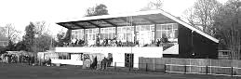
We also played there that season in the Surrey Senior Cup, winning 2-1 at Walton Road following a 1-1 draw at West Street in the first match and later in two Southern Combination Cup ties in 1994 and 1995, losing the first embarrassingly 3-0 on penalties after a 3-3 draw but winning the second tie 1-0.

We wouldn’t meet again until our paths crossed in the Isthmian League First Division South for 2002/03 following our promotion in the League reorganisation. Despite the step up of two divisions for our boys, we defeated them 1-0 home and away to record our first ever League win there (despite having won at Walton Road in four other competitions) and our first League double. We even won one of the two matches in our disastrous 2003/04 campaign but still went down.

Since 2008 we have met as members of the Combined Counties League and most of the matches have, if I’m honest, been dull ones as both sides cancelled each other out. We did register a fine but flattering 4-0 win at Walton Road on 16th March 2010 but suffered a pitiful 6-0 home defeat at Moatside almost exactly two years later. In between we had a couple of narrow home victories and a bad tempered 3-0 away defeat when we finished with nine players, although one of the red cards was rescinded at appeal. Last year we won 2-1 at Walton Road but were held 2-2 at home, requiring a Karl Douglin equaliser despite taking a lead in the match.

This season we have found an improved Molesey side that have defeated us twice. Financially, they are now more stable following the sale of part of their ground for housing and have relocated the pitch by ten yards, necessitating the removal of their covered terrace. Whether they will go up this season remains to be seen but they have every chance and our visit there in April could be our last for a while. We shall see!
The main stand at Molesey, not as central as it used to be, following the pitch move

Have you seen our website?
For those who are unaware, our website, now over a year old, contains everything you could possibly want to know about the club and an enormous amount you may not have been aware of!

Our previous site still exists but as a photo archive only, housing the thousands of pictures provided by Gemma Jarman, our Club photographer. In addition, there are over a thousand historical images of teams, players, action shots and programme covers.

As you can tell from this screenshot of our front page, there is a substantial amount of information all available at the touch of a button, which is also very useful if you own one of those new touchscreen personal computers that are becoming more and more popular these days.
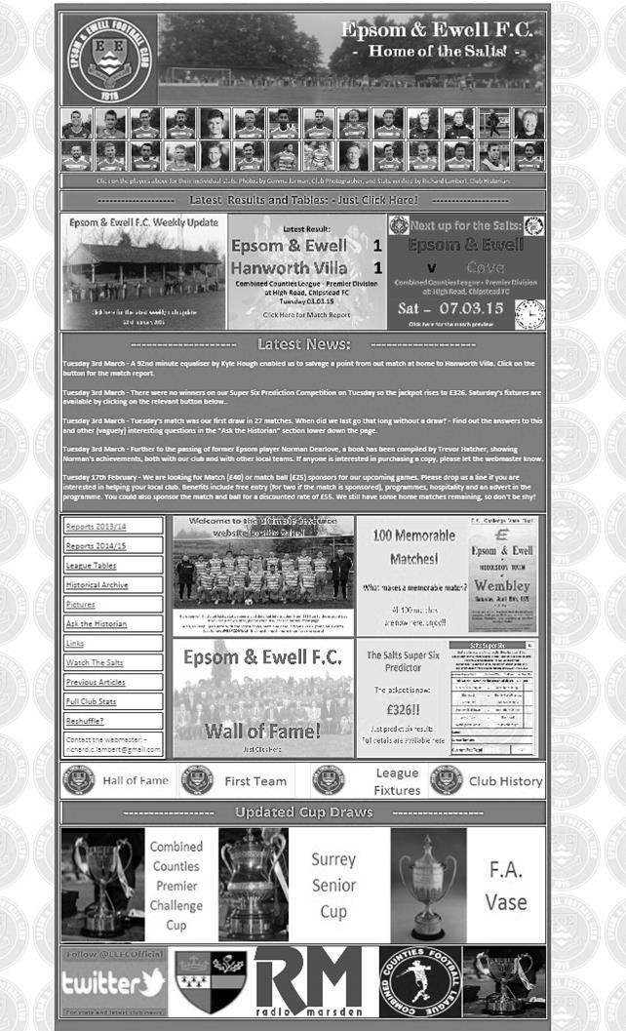
If you are a supporter, please pass the address on to anyone you know that has ever expressed an interest in the club, especially those who don’t visit any more. You never know, some of them might be inspired to come along too, and bring their friends, family etc.

http://www.eefconline.co.uk/

Club Statistical History - (including Hanworth Villa match on 03/03/15):
League: Played: 2,783, Won: 1,132, Drawn: 528, Lost: 1,123
For: 5,098, Against: 4,970, GD: plus 128 - Win Ratio 40.68%

CCL only: Played: 362, Won: 158, Drawn: 70, Lost: 134
For: 632, Against: 584, GD: plus 48 - Win Ratio 43.65%

Cup and Other: Played: 1,092, Won: 518, Drawn: 127, Lost: 439
For: 2,374, Against: 2,038, GD: plus 336 - Win Ratio 47.44%

Abandoned Matches: Played: 8: For: 14, Against: 16

Under Glyn Mandeville: Played 27, Won: 12, Drawn: 1, Lost: 14
For: 51, Against: 56, GD: minus 5 - Win Ratio 44.44%

Total: Played 3,875, Won: 1,650, Drawn: 655, Lost: 1,562, Aban: 8
For: 7,472, Against: 7,008, GD: plus 464 - Win Ratio 42.58%

First Senior Match: 30th August 1924.
Lost 1-3 vs Dorking at our home ground at the time of Horton Hospital Grounds.

First Match Programme Issued: 15th September 1923.
Won 4-0 vs West Norwood Reserves - Friendly match at Horton Hospital Grounds.

Number of Official Home Grounds: Six.

Alexandra Recreation Ground 1918-1922,
Horton Hospital Grounds 1922-1925,
West Street 1925-1993,
Merland Rise 1993-2010,
Moatside 2010-2012,
High Road 2012- present.

Record Win: 12/10/1935. 13-1 v Reigate Priory (H) - Amateur Cup.

Record Defeat: 14/02/1948. 0-14 v Chelmsford City Reserves (A) - London League.

Longest Serving Manager: 1) Adrian Hill 853 1982-1985 & 1990-2003
2) Pat O’Connell 466 1973-1982
3) Lyndon Buckwell 407 2006-2014
4) Ricky Kidd 190 1986-1990

Record Appearances: 1) Graham Morris 658 1990-2004
2) Nigel Bennett 630 1989-2005
3) Tommy Tuite 582 1973-1987
4) Ernie Watkins 419 1945-1960

Record Goal Scorers: 1) Tommy Tuite 391 1973-1987
2) Reg Marlow 254 1924-1936
3) Jimmy Jones 148 1933-1945
4) Kyle Hough 137 2007-present

Most Appearances in a season: Tony Coombe and Tommy Tuite - 59 in 1980/81.

Most goals in a season: Reg Marlow - 65 (at least) in 39 appearances in 1926/27.

Senior League Titles: 5 - 1925/26 Surrey Senior League - 1926/27 Surrey Senior League - 1927/28 London League - 1974/75 Surrey Senior League - 1977/78 Isthmian League Division Two

Player Sponsorship
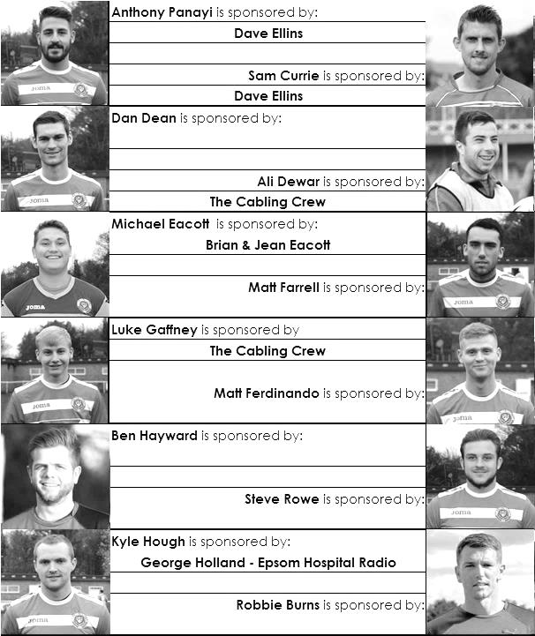

Here is the latest list showing all of the players and Management available for sponsorship. Sponsorship costs just £40 so if you want to help the club, the player and get your name in the programme for the season, let us know before they go!

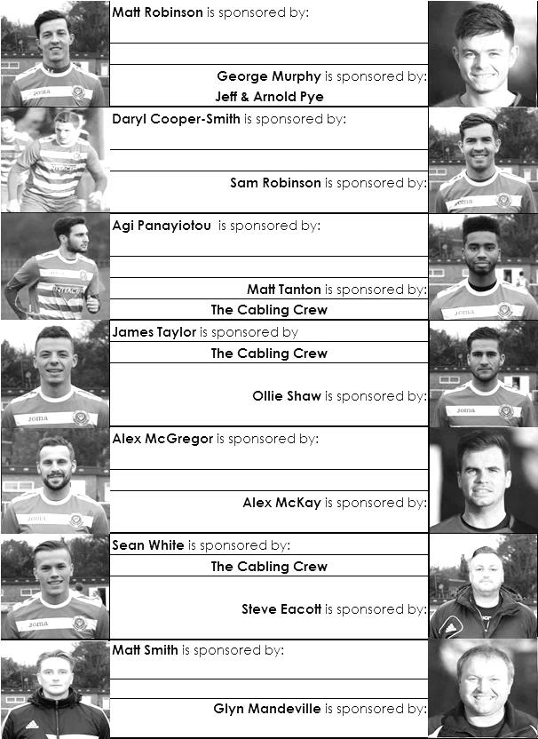

Match and Ball Sponsorships – 2014/15
Opponent | Date | Match Sponsor | Ball Sponsor
Raynes Park Vale | 05/08/14 | Club President - Stella Lamont
Horley Town | 25/08/14 | EEFC Management Committee
Croydon (FAC) | 30/08/14 | EEFC Media Officer - Richard Lambert
Frimley Green | 13/09/14 | Dave Gaffney and friends
Guildford City | 30/09/14 | The Jarman family
Mole Valley SCR | 07/10/14 | Mark and Carmel Murphy
Bedfont Sports | 11/10/14 | Epsom & Ewell F.C. Colts
Knaphill (LC) | 14/10/14 | Geoff and Steve Dyke
Ashford Town (Mx) | 18/10/14 | The Building Shop, Bookham
Chertsey Town | 28/10/14 | In Memory of Bob Bexley
Molesey | 22/11/14 | The Cabling Crew 0208 -224 4110
Camberley Town (SSC) | 02/12/14 | In memory of Liz and Doug Burns
Spelthorne Sports | 16/12/14 | long serving supporter Paul Merritt
Windsor | 03/01/15 | Ezara Beddoe
Farnham Town | 17/01/15 | In memory of Chris Henry
Camberley Town | 07/02/15 | Former player Marvin Hough
Hartley Wintney | 21/02/15 | Steve and Geoff Dyke
Camberley Town (LC) | 24/02/15 | Epsom & Ewell Colts FC
Hanworth Villa | 03/03/15
Cove | 07/03/15 | The Building Shop, Bookham
Badshot Lea | 21/03/15 | Vince Romagnuolo
Westfield | 24/03/15
Colliers Wood United | 04/04/15 | Nathan Lambert
Knaphill | 18/04/15
For League, League Cup and Surrey Senior Cup Matches:

Match sponsorship - £40.00 Match ball sponsorship - £25.00.
Combined Offer of Match and Match Ball sponsorship for £55.00.

For F.A. Cup and F.A. Vase matches:

Match sponsorship - £50.00 Match ball sponsorship - £30.00.
Combined Offer of Match and Match Ball sponsorship for £65.00.
----------------------------------------------------------------------------------------------------------------------------
Sponsorship includes: (x2 for match, x3 for match and ball)

Admission, programmes, hospitality and advertising and mascot for the day (if required).

If you are interested, just speak to a Committee Member, you know where we are!
Alternatively, drop me an email at: richard.c.lambert@gmail.com

Salts Super Six Predictor
The Salts Super Six Predictor is live again. The next matches are TODAY and tickets are on sale at today’s game to the left of the gate.

The competition is easy to play and you don’t even have to be at the match! To win, you simply need to predict the results of six matches correctly from the three options, fill in the form and make sure it is back with one of our distributors before the deadline on the ticket. The latest fixtures are shown here.

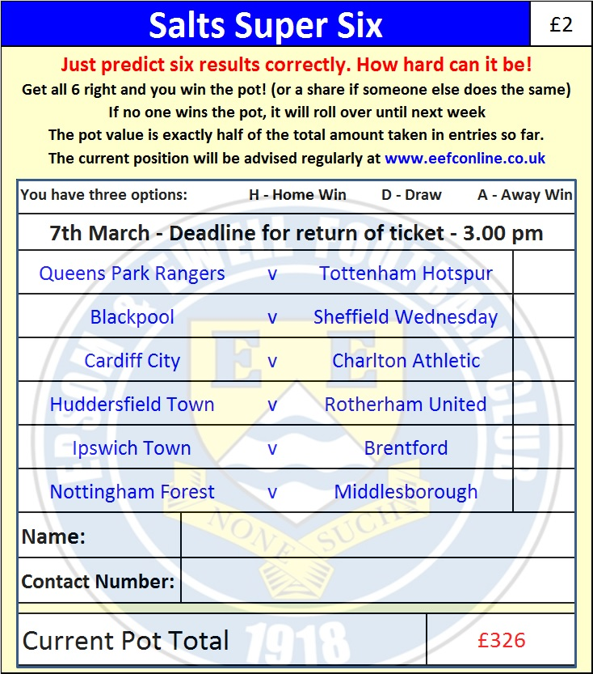
If you are a club regular, you just need to place your name on the sheet, although if you aren’t, then we’ll need a contact number from you too. We will announce any winners on the website within three working days, so don’t worry, we won’t miss you!

The prize pot is currently £326 but will continue to go up, if unclaimed, by the cost of 50% of all the sold tickets. In other words, if we sell 50 tickets at £2 before the deadline, and the pot isn’t won, then the next prize would be £376! You’ll always know the size of the pot before you enter.

Please note that if there is more than one winner, the prize pot would be shared between the winners. All you need to do now is have a go, as many times as you like!

Good luck!

Combined Counties League - Premier Division
Saturday, 7th March 2015 - Kick-off 3.00 p.m.
Epsom and Ewell  (Royal Blue & White hoops) | V |  | Cove  (Yellow and Black)
 | NUMBERS
Conor Jack Young |  |  | Stuart Harris
James Taylor |  |  | Toby Janaway
Steve Rowe |  |  | James King
Anthony Panayi |  |  | Julian Sills
© Sam Currie |  |  | Liam Eagle
Dan Dean |  |  | Joe Paris
Matt Ferdinando |  |  | Adam Everiss
Matt Farrell |  |  | Aaron Parfitt
Kyle Hough |  |  | Jake Baxter
Sam Robinson |  |  | Jack Coventry
Alex McGregor |  |  | Steve Duff
Daryl Cooper-Smith |  |  | Chris Musgrove
Alex McKay |  |  | Paul Coventry
Matt Robinson |  |  | Patrick Kirby
Ben Franklin |  |  | Liam Fisher
Savva ‘Agi’ Panayiotou |  |  | Dan Akinwande
George Murphy |  |  | Jacob Peace
Ali Dewar
Robbie Burns
Michael Eacott
Glyn Mandeville | MANAGER |  | Antony Millerick
Matt Smith | ASSISTANT |  | Dave Huntingford
Steve Eacott / Alex McKay | COACHES |  | Mark Hurst
Ken Jones | PHYSIO |  | Mike Beard
REFEREE: S.Hawkes (Aldershot)
ASSISTANTS: R.Wells (Coulsdon), P.Saunders (Knaphill)
Today’s match and ball are sponsored by:
The Building Shop, Bookham

OUR NEXT VISITORS TO HIGH ROAD
Badshot Lea
Saturday 21st March 2015 - Kick-off 3.00 p.m.
Combined Counties League – Premier Division

